**DATA VISUALIZATION**

**AIM:**

To import

Data Visualization packages and do the basic functions.

**PROGRAM:**

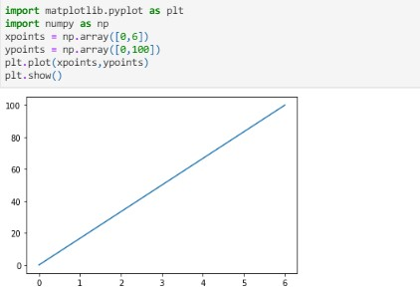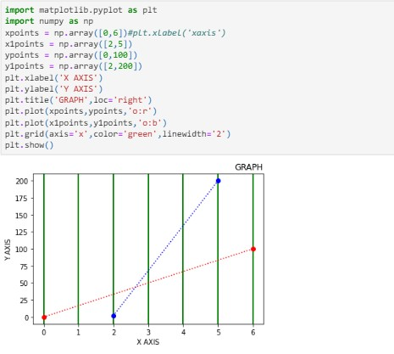

**EX.NO:**

**DATE**

**:**

05

28/03/2024

220801140

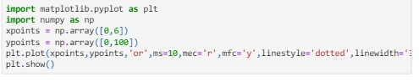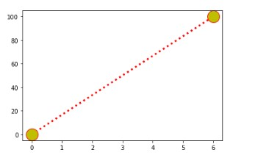

220801140